PROGRAMS USING RAPTOR:

1.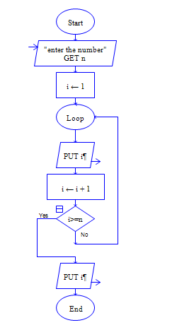 GENERATION OF NATURAL NUMBERS :

2. GENERATION OF EVEN NUMBER SERIES:

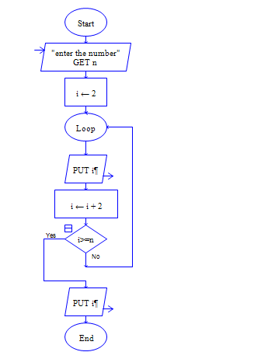

3.GENERATION OF ODD NUMBERS:

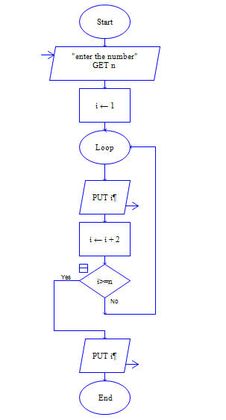

4.SUMMATION OF NATURAL NUMBERS:

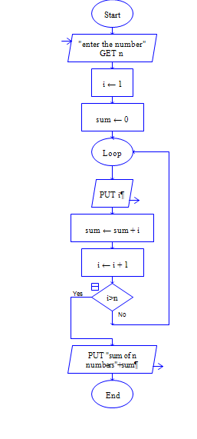

5. SUMMATION OF EVEN NUMBER SERIES:

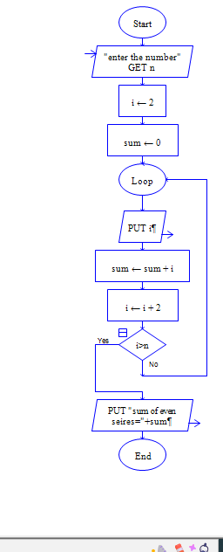

6.SUMMATION OF ODD NUMBER SERIES:

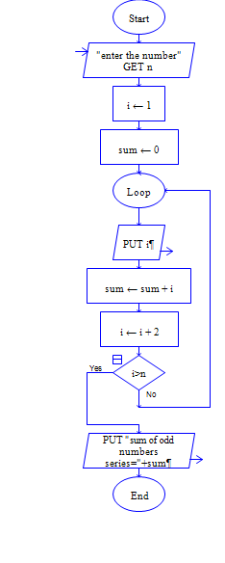

7. SUMMATION OF SQUARE OF NATUTRAL NUMBERS:

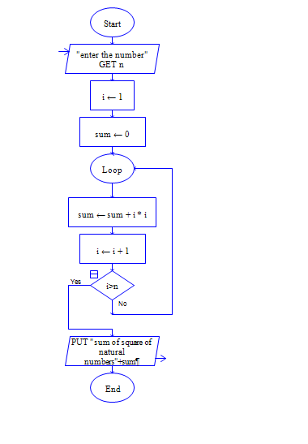

8. SUMMATION OF SQUARE OF EVEN NUMBERS:

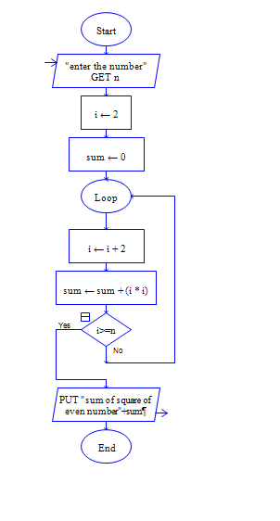

9. SUMMATION OF SQUARE OF ODD NUMBERS:

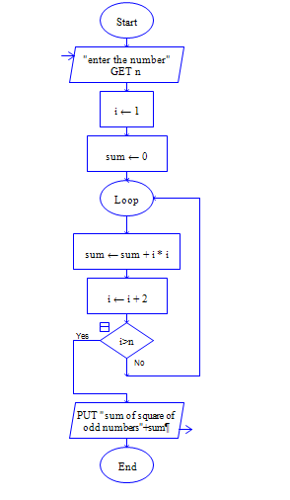

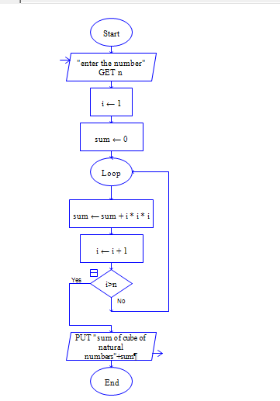10. SUMMATION OF CUBE OF NATURAL NUMBERS:

11. SUMMATION OF CUBE OF EVEN NUMBERS:

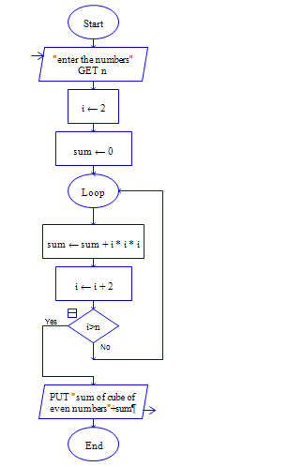

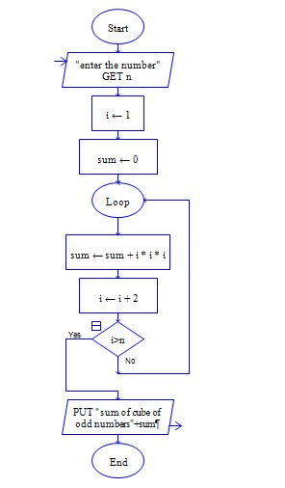12. SUMMATION OF CUBE OF ODD NUMBERS: